# Credit Card Record System 2.0 – Michael Ragsdale

## “Before” Usage Screen Shot

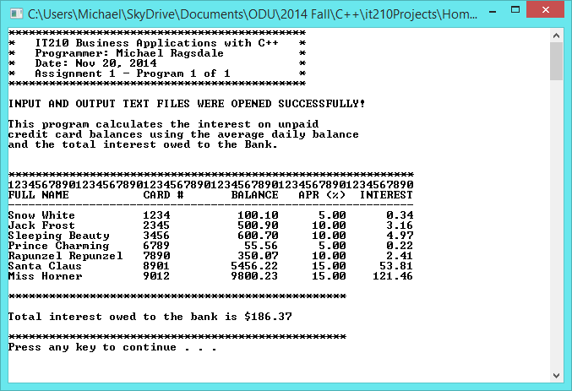

# Credit Card Record System 2.0 – Michael Ragsdale

## “After” Usage Screen Shot

